RV College of Engineering®, Bengaluru – 59 Department of Computer Science and Engineering Introduction to Database Laboratory (21CS53)

Forms,Tables and Validation

|  |  |  |
| --- | --- | --- |
| **TITLE: Electricity Billing System** | | |
| **TEAM** | USN: 1RV21CS150 | Name: Sharath Chandra K |
| USN: 1RV21CS135 | Name: Sadiq Wahid Tugoo |
| USN: 1RV21CS141 | Name: Samiksha Ranjan |

# Forms

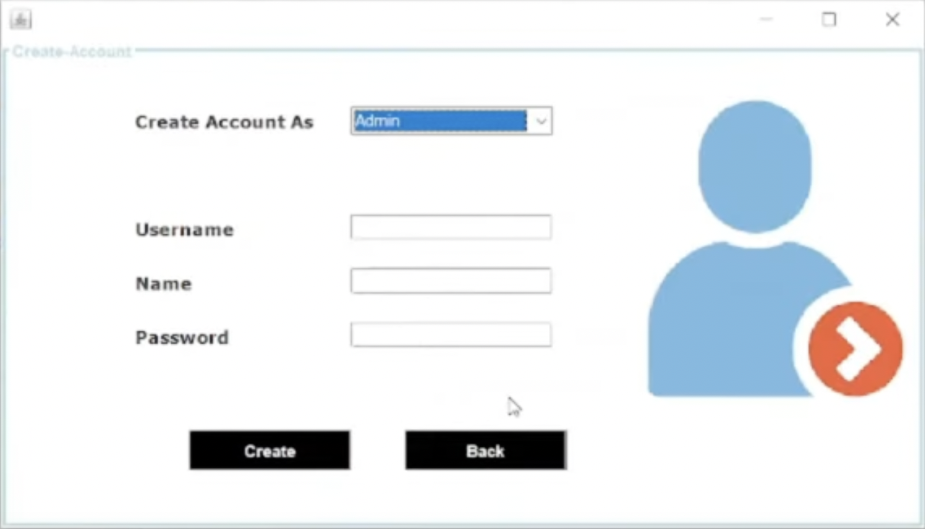

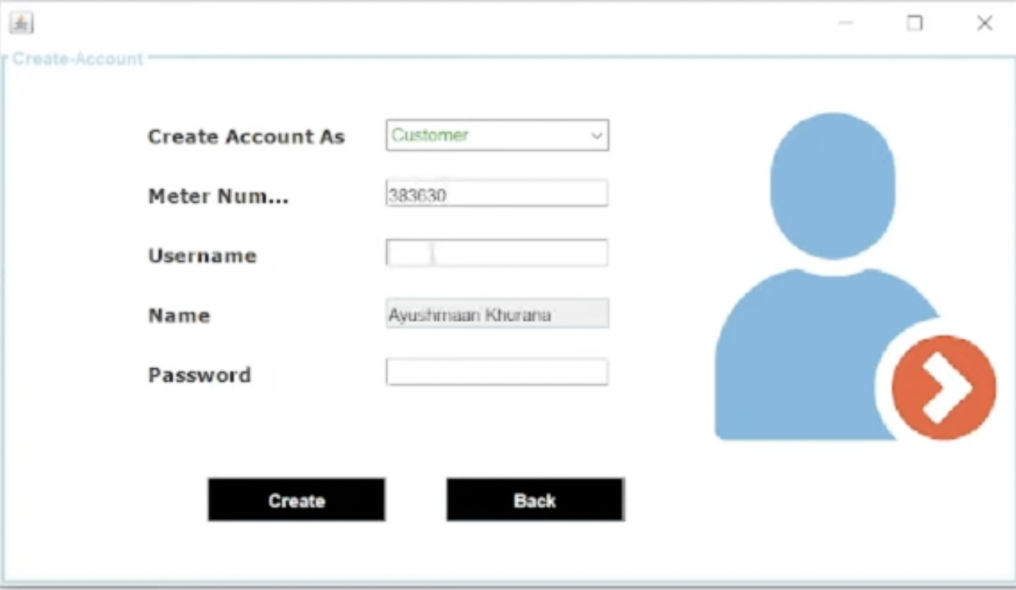

1. **Database Tables**

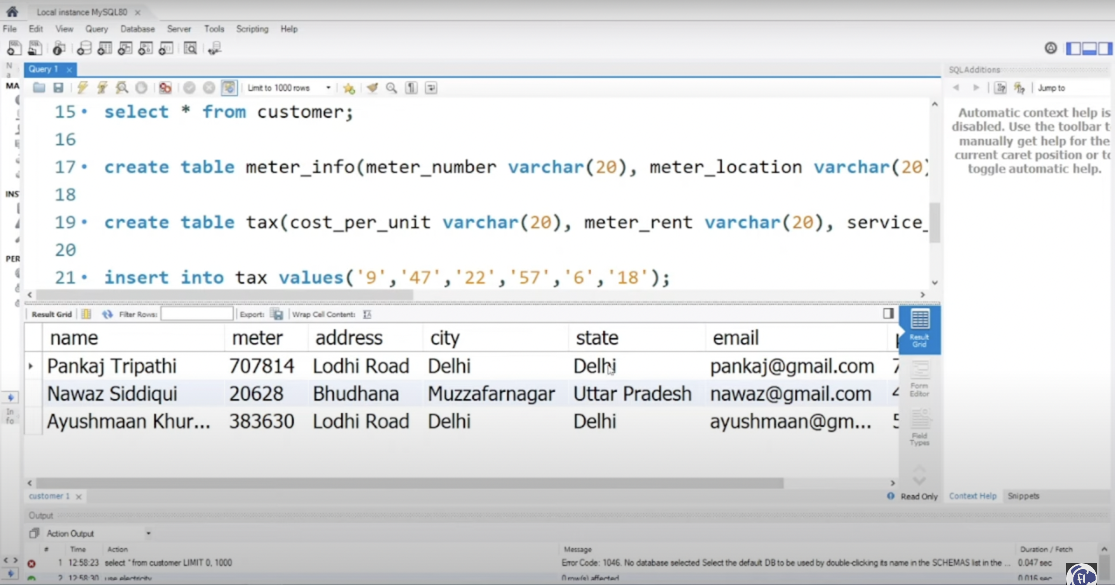

# Validations

